

27

Target: ___/27 or ____ % 👍 👎

Year 9 HASS- Geography

40

40

***Task 5 Part A: In Class Assessment Fieldwork Theory***

***And Skills Assessment (2.5 % weighting)***

***Reading Time: 5 minutes & Working Time: 35 minutes***

Name: Teacher:

1. What type of photograph is Source 3? **(1 mark)**

Aerial photograph

1. Describe what is shown in Source 1. Consider cultural (built) features and natural (physical) features. **(4 marks)**

* Year 10 area NSHS
* Scaffolding
* Basketball ring
* Tall trees behind/beside the two story white building
* Vegetation behind basketball ring to the side of the two story building
* Brick paving
* Bitumen/asphalt
* Two story white building
* Brick building with tiled roof in the foreground
* Table and chairs
* Sunny day
* Limestone stairs and wall
* Building in progress
* Second basketball ring
* Covered drain

1. Describe what is shown in Source 2. Consider cultural (built) features and/or natural (physical) features. **(4 marks)**

* Year 10 area NSHS
* Basketball ring
* Brick paving
* Bitumen/asphalt
* Two story white building
* Brick building with tiled roof in the foreground
* Limestone stairs and wall
* Vegetation behind basketball ring to the side of the two story building
* Cloudy day
* Second basketball ring
* Veranda – Awning – Covered area over the limestone wall paved area
* Covered drain

1. Explain the change that has happened over time between Source 1 and Source 2.

**(6 marks)**

The Year 10 area at NSHS has changed over time:

* Source 1 has trees behind/to the side of the two story white building whereas Source 2 does not.
* Source 1 is a building site whereas Source 2 is not.
* Source 1 has table and chairs on the bitumen whereas Source 2 does not.
* Source 1 was a photograph taken on a sunny day whereas Source 2 was a photograph taken on a cloudy day.
* There is scaffolding present in Source 1 whereas Source 2 has no scaffolding.
* Source 1 does not have a veranda – Awning – a Covered area - over the limestone wall paved area whereas Source 2 does have a competed covered area.

**SOURCES: Refer to the following images to answer Assessment 5A.**

**Please do not mark this page.**

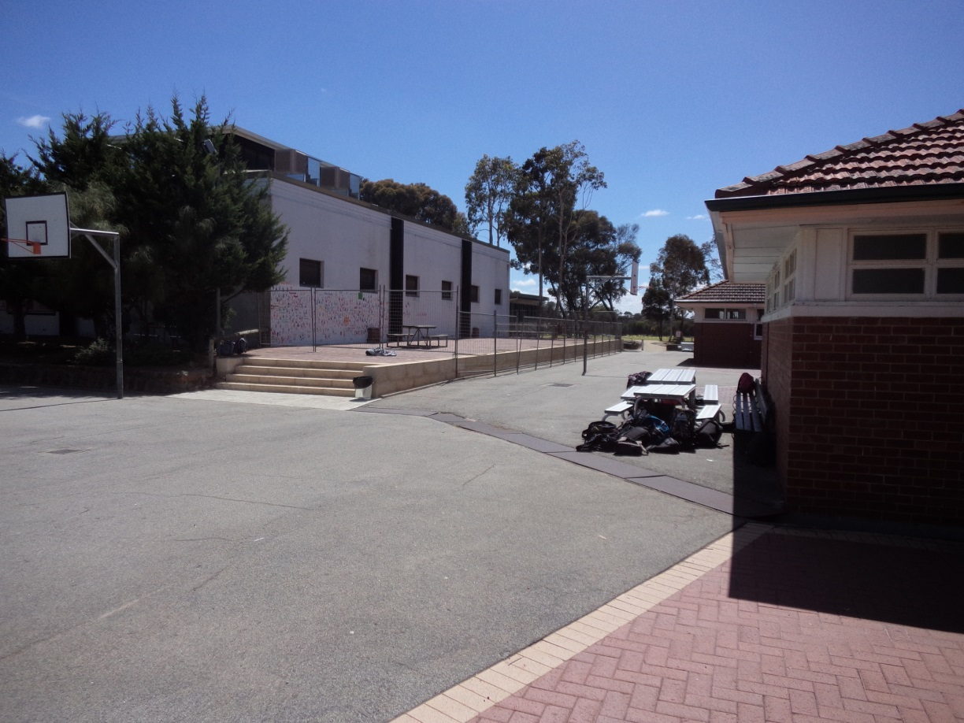

**Source 1:**

**Around 2016**

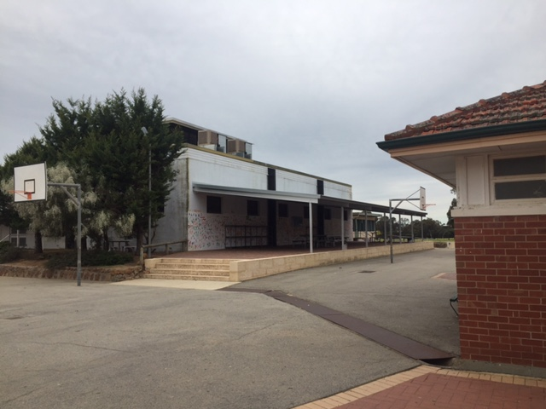

**Source 2:**

**2017**

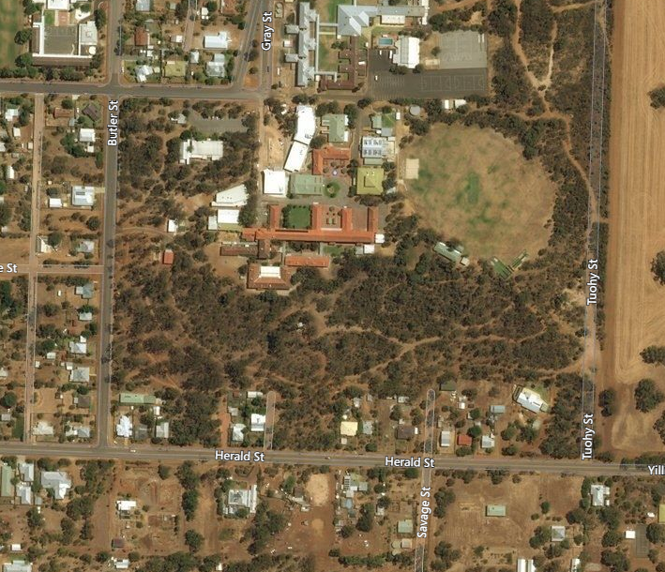**Source 3:**

My Map Street View, <http://mymapstreetview.com/earth/?t202id=3199&c1=GGS-MyMapST&t202kw=google%20earth&gclid=EAIaIQobChMImNfvyI2k1gIVDr69Ch0k2geYEAAYASAAEgKB5_D_BwE>, retrieved on 14/9/17

**Source 4:**

